Nathaniel Lawson DMD PhD
UAB School of Dentistry
Birmingham AL

Email: nlawson@uab.edu
Cell: 219-789-2448
Website: drnatelawson.com
Instagram: @dentinaltube

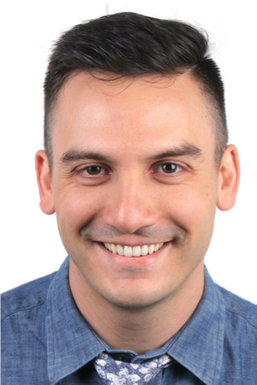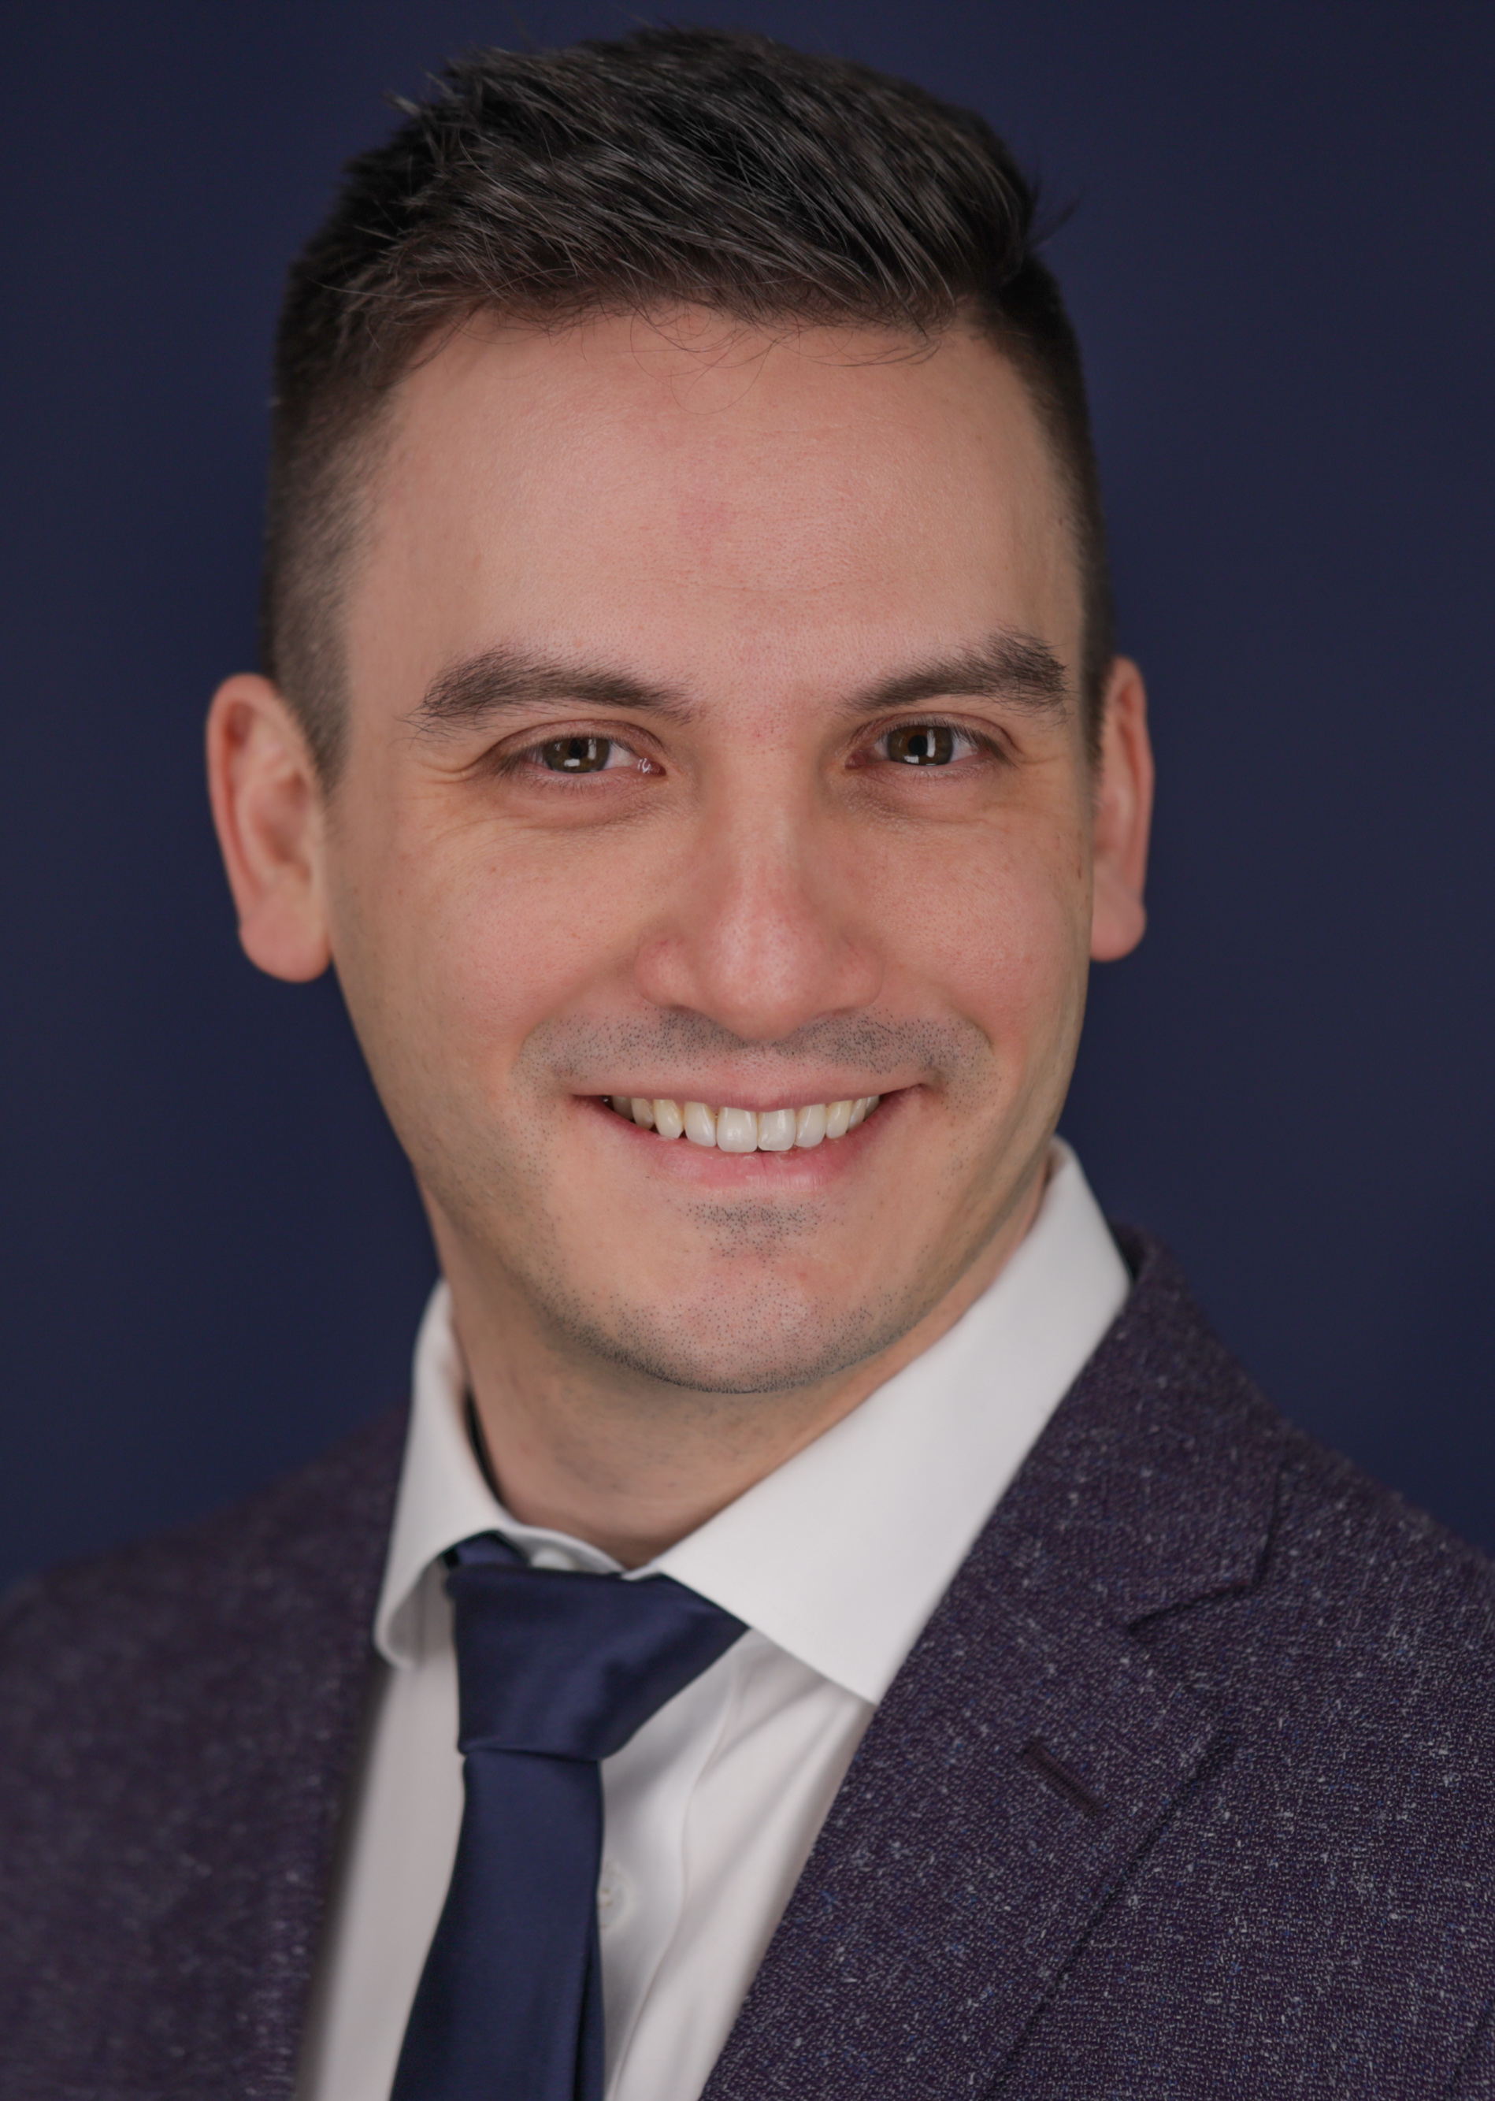

Nathaniel Lawson DMD PhD is the Director of the Division of Biomaterials at the University of Alabama at Birmingham School of Dentistry and the program director of the Biomaterials residency program. He graduated from UAB School of Dentistry in 2011 and obtained his PhD in Biomedical Engineering in 2012. He has served as an investigator on over 75 clinical and laboratory research grants, and published over 200 peer reviewed articles, book chapters, and research abstracts. His research interests are the mechanical, optical, and biologic properties of dental materials and clinical evaluation of new dental materials. He was the 2016 recipient of the Stanford New Investigator Award and the 2017 Innovative Research Fellowship both from the American Dental Association. He serves on the American Dental Association Council of Scientific Affairs and is on the editorial board of The Journal of Adhesive Dentistry and Compendium. He has lectured nationally and internationally on the subject of dental materials. He also works as a general dentist in the UAB Faculty Practice.

Half-day lectures

These 2 programs may be combined into a full-day course (4-6 hours).
Also, these programs may be shortened to 1 hour courses.

An update to dental ceramics (3 hours)

90% of crowns and bridges are now fabricated from a ceramic material according to a report from one of the largest US dental laboratories. Ceramic materials do not handle the same as metal-based restorations and improper selection or handling can lead to premature failure. This course will teach you how to select and handle different types of ceramic materials that are currently used in dentistry that will be much less confusing than typical marketing rhetoric. The ability to bond these dental ceramics allows the practitioner to perform more conservative tooth preparations. As there are many different types of dental ceramics available (zirconia, lithium disilicate, porcelain, processed composite, etc), determining the correct protocol for each type of ceramic can be confusing. This lecture aims to simplify the process of bonding ceramics and provide the clinician with a protocol that can be used to bond any type of dental ceramic. In this course, we will review the best clinical practices based on research studies conducted at the UAB School of Dentistry and provide pearls for you to take back to the office.

Course objectives
- Review the different types of dental ceramic materials
- Choosing a ceramic material for anterior restorations
- Preparation and design considerations for posterior crowns and bridges
- Strategies to adjust, polish and cut off ceramic crowns
- Review the indications for bonding dental ceramics
- Present a protocol for preparing the surface of ceramic crowns (ie etching, sandblasting, priming, cleaning)
- Classify the types of cements used for adhesive bonding

Materials and techniques to improve posterior composites (3 hours)

Posterior composite restorations remain the bread-and-butter procedure of many general dentists. Although this procedure may seem trivial, there are many clinical factors which lead to a long-lasting restoration, including diagnosis, isolation, caries removal, cavity preparation, use of liner, matrix and wedge placement, bonding technique, composite placement, and finishing and polishing. This course aims to review the techniques for each of these steps based on current evidence.

Course objectives
- Discuss treatment guidelines for interproximal caries and caries removal endpoints.
- Discover materials and techniques to promote a long lasting adhesive bond and create a well-adapted restoration.
- Analyze matrix utilization and contouring instruments to achieve a tight and well-contoured contact.

Shorter lectures

These programs may be mix-and-matched to form a program of a desired length.

Prevention and non-surgical treatment of caries (1.5 hours)

Despite our best efforts to restore natural dentition with adhesive dentistry, all restorations are inferior to natural tooth structure and susceptible to secondary caries. This lecture presents a simple approach for treating caries based on the risk factors of our patients. We will discuss new products and techniques used to arrest caries (such as Silver Diamine Fluoride) as well as review time-tested approaches (such as fluoride-containing products and diet modification recommendations). This course if friendly for the entire dental team (including dentists, hygienists, and assistants).

Course objectives
- Review four distinct types of high caries risk patients
- Present protocols and techniques for treating each type of high caries risk patient
- Review the evidence for fluoride

Treatment of anterior discolorations (1.5 hours)

Discoloration of anterior teeth can result from a disruption in mineralization of the forming tooth or from the process of caries on the formed tooth. Both dysmineralization and white spot lesions may be an esthetic concern for many patients. Resin infiltration and microabrasion are 2 different conservative treatments for these discolorations. This lecture will review clinical tips for case selection for both types of treatment as well as the steps to perform both techniques.

Course objectives
- Review the clinical signs to determine which cases will have the best chance for success with microabrasion or resin infiltration
- Review the clinical steps to perform microabrasion and resin infiltration
- Present clinical cases with both treatments

Bioactive materials (1.5 hours)

Bioactive has become a buzz word in dentistry, however, many of us struggle to define exactly what that term means. This lecture will present the bioactive claims of both pulp capping materials and restorative materials as well as the evidence for these claims. Clinical examples of the use of these materials will be presented.

Course objectives
- Review the claims and evidence for bioactive pulp capping and restorative materials
- Present clinical cases using these materials
- Report some of the future directions of bioactive material development

